# Sennheiser equips the new Morgan Supersport with a high-fidelity audio system

**Tradition and innovation combine to create an exhilarating driving experience in the new Morgan Supersport featuring a high-fidelity Sennheiser audio system.**

***Wedemark, 11 March 2025* - Sennheiser, a leader in superior immersive in-car audio solutions with their mobility offering, announces that the partnership with Morgan that began in 2022 continues with Morgan’s latest model, the Supersport. As the new flagship Morgan, the Supersport confidently introduces a new level of usability, refinement and driving engagement, including an enhanced Sennheiser audio system.**

The Sennheiser audio system provides a high-fidelity audio experience, featuring a high dynamic range and loudness levels to match the driving experience, ensuring clear and balanced sound. ​

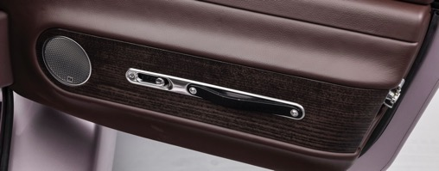

The system is designed to offer a tight and focused low end, with the soundstage expanding in width as the frequencies rise. It utilizes lightweight and efficient actuators in the dashboard for higher frequencies, moving-coil drivers in each door for mid-range reproduction, and a ported subwoofer behind the seats for low-end and sub frequencies. Additionally, actuators in each seat enhance the bass sensation, allowing occupants to feel the music. ​ ​

Utilizing pioneering actuators ensures that the system remains lightweight, allowing for high-quality audio without adding additional weight to the vehicle. ​ ​

“With the introduction of Morgan’s Supersport model, Sennheiser’s in-car audio experience for Supersport, Plus Four, and Midsummer drivers and passengers will continue to offer an unmatched entertainment and communication experience,” said Veronique Larcher, Managing Director at Sennheiser Mobility.

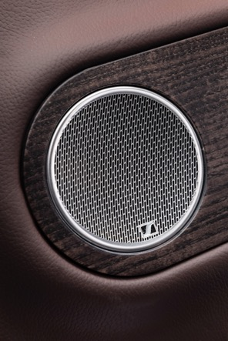

Sennheiser will celebrate 80 years of audio technology leadership this year, making Sennheiser a perfect match for the Morgan Motor Company’s illustrious history of traditional craftsmanship and modern technology. The partnership has resulted in a clear focus on design with technological excellence in a system that features Sennheiser’s signature sound, aligning with the sports car manufacturer’s unique blend of craft, adventure, and analogue driving experience.

To find out more about Morgan Motor Company and the Supersport partnership, visit [morgan-motor.com](https://morgan-motor.com/supersport/).

(Ends)

**About the Sennheiser brand**

We live and breathe audio. We are driven by the passion to create audio solutions that make a difference. Building the future of audio and bringing remarkable sound experiences to our customers – this is what the Sennheiser brand has represented for more than 75 years. While professional audio solutions such as microphones, meeting solutions, streaming technologies and monitoring systems are part of the business of Sennheiser electronic SE & Co. KG, the business with consumer devices such as headphones, soundbars and speech-enhanced hearables is operated by Sonova Holding AG under the license of Sennheiser.

[www.sennheiser.com](http://www.sennheiser.com)

[www.sennheiser-hearing.com](http://www.sennheiser-hearing.com)

**Sennheiser Mobility Press Contacts**

Felix Teufel

felix.teufel@sennheiser.com

Sarah Talaat

sarah.talaat@sennheiser.com

+49 152 22851987